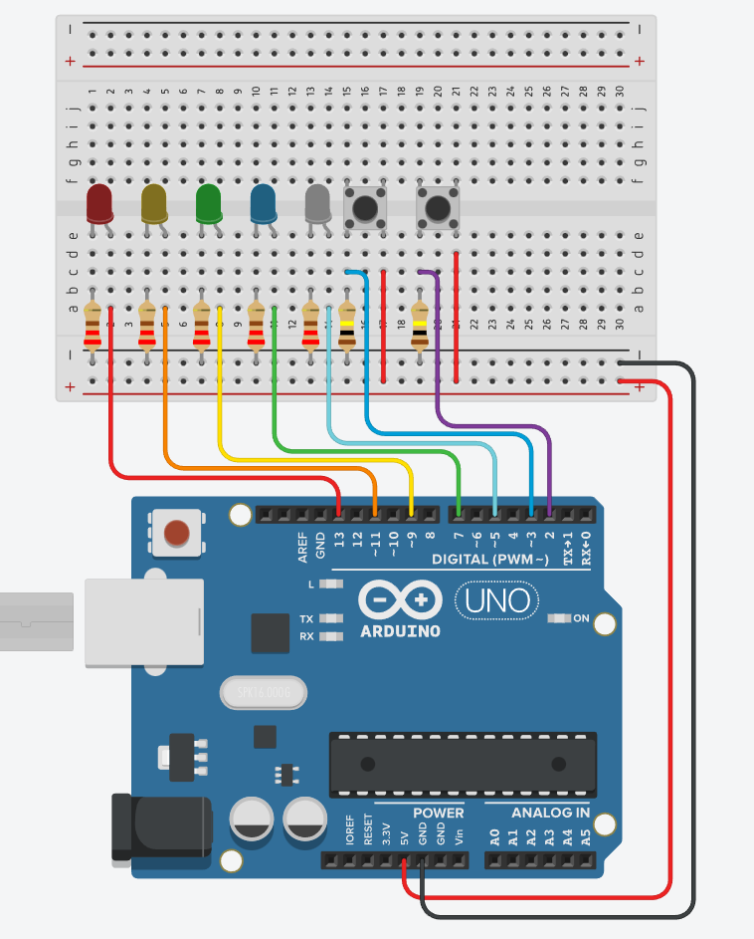

int i=0;
int length=12;
int tim=5;
unsigned long tempTime=0;
boolean button2pressed=false;
static int arr[]={0,1,2,3,0,1,2,3,0,1,2,3};
static int nums[4]={13,11,9,7};
static int led1=13;
static int led2=11;
static int led3=9;
static int led4=7;
static int led5=5;
static int button1=3;
static int button2=2;

void setup(){
pinMode(led1, OUTPUT);
pinMode(led2, OUTPUT);
pinMode(led3, OUTPUT);
pinMode(led4, OUTPUT);
pinMode(led5, OUTPUT);
pinMode(button1, INPUT);
pinMode(button2, INPUT);
}

void loop(){
if (digitalRead(button1)==HIGH){
if (button2pressed){
button2pressed=false;
}else if (!button2pressed) {
button2pressed=true;
}
delay(100);//bounce back
}
if (digitalRead(button2)==HIGH||button2pressed){
digitalWrite(led5, LOW);
redLEDS(arr, tim, nums);
}else{
digitalWrite(led4, LOW);
digitalWrite(led3, LOW);
digitalWrite(led2, LOW);
digitalWrite(led1, LOW);
digitalWrite(led5, HIGH);
}
delay(100);
}

void redLEDS(int array[], int time, int LEDNumbers[]){
if (millis()-tempTime<=time*100){
if (i<length){
digitalWrite(LEDNumbers[array[i]], HIGH);
}else{
i=0;
}
}else{
digitalWrite(LEDNumbers[array[i]], LOW);
tempTime=millis();
i++;
}
}

